Your First Impression
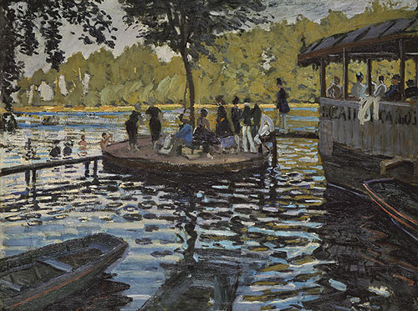
Claude Monet, La Grenouillere, 1869

What is this work about?
- What is this painting of?

- Which art element (Line, Color, Shape, Texture, Value, Space, or Form) is dominant in this painting?

- What does the artist want you to see, think, feel, or notice?

- What do you think inspired this artist to make this painting?

- What do you think the Impressionist style known for? Why is it Important?

