The Judgment of Paris, ca. 1510–20  Marcantonio Raimondi (Italian, ca. 1480–before 1534); Designed by Raphael (Raffaello Sanzio or Santi)  http://www.metmuseum.org/toah/works-of-art/19.74.1  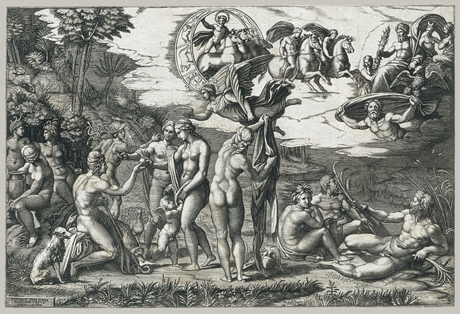  ___________________________________________________________________________________________________________________________________________________________________? | The Pastoral Concert, 1509  Titan  http://www.louvre.fr/en/oeuvre-notices/pastoral-concert  ___________________________________________________________________________________________________________________________________________________________________?
Edouard Manet (1832-1883)Lunch on the Grass 1863Oil on canvasH. 208; W. 264.5 cmParis, Musée d'Orsay  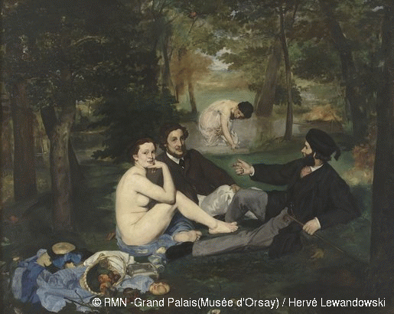  http://www.musee-orsay.fr/index.php?id=851&L=1&tx_commentaire_pi1%5BshowUid%5D=7123  ___________________________________________________________________________________________________________________________________________________________________? | Pablo Picasso  Le Dejeuner sur l’herbe 27 February 1960  Courtesy Nahmad Collection, Switzerland  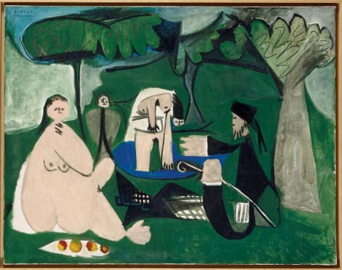  http://www.tate.org.uk/whats-on/tate-liverpool/exhibition/picasso-peace-and-freedom/picasso-peace-and-freedom-explore-6  ___________________________________________________________________________________________________________________________________________________________________?
Look at each image carefully and choose 1. Think of AT LEAST 3 questions about the context in which the work was made that would help you thoroughly interpret this artwork. Write your questions under the artwork you choose.

Choose one of the artworks above to interpret.
Make and Explain 2 connections between the artwork and social, cultural, and/or political history.

Defend your two connections.

HS Accomplished VA:Pr6.1.IIa
Make, Explain and Justify connections between artwork and social, cultural and political history.

