Stop Motion Animation Planning
Group Members:
Transformation: Describe the basic concept of your animation in a few brief sentences.

Plot Structure: Write what will happen in your story in the areas beneath the diagram.
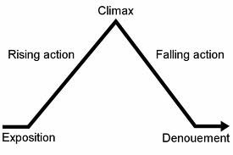

Story Board
In the boxes below, illustrate the major events in your story. Include and add details to your illustration. In the box beside your illustration, describe the event in a few brief sentences, and explain why this imagery is important to the theme of your story.
TITLE:________________________________________________
Exposition
Rising Action
Climax
Falling Action
Denouement

