REMAKE A SURREALIST ARTWORK
Change something in the painting to alter the original surrealist work. Choose something that contrasts the surroundings and creates interest using Juxtaposition (placement of two unlikely objects next to one another)
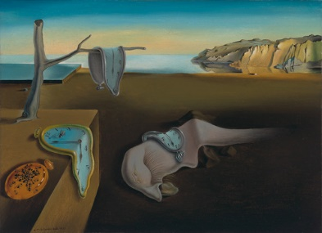
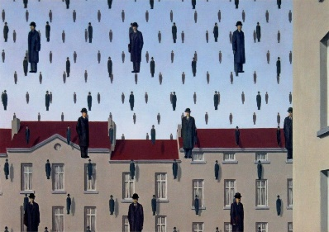
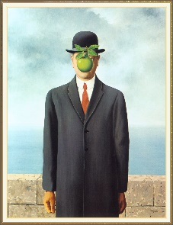

REMAKE A SURREALIST ARTWORK
Change something in the painting to alter the original surrealist work. Choose something that contrasts the surroundings and creates interest using Juxtaposition (placement of two unlikely objects next to one another)

REMAKE A SURREALIST ARTWORK
Change something in the painting to alter the original surrealist work. Choose something that contrasts the surroundings and creates interest using Juxtaposition (placement of two unlikely objects next to one another)

