Order in the Courtroom!
You and a partner are going to act as lawyers defending an artwork. You are up against a class of suspicious jurors who need to be convinced of an artworks evaluation. Evaluating a work of art means stating the work’s purpose or value (should it be kept or thrown out and why). To convince the jury, you and your partner need at least 3 pieces of evidence. Look at the artwork below as an example.
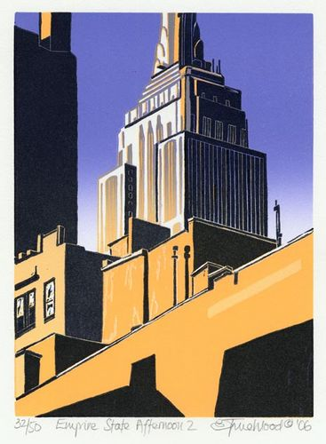
Example:

Evaluation:
I believe this work should be kept and cherished for the following reasons:
1. The work is beautiful to look at. The use of light blue and the vibrant but soft yellow-orange complement each other. One is positioned on mostly the bottom half and the other on the top half create balance.
2. The artwork also contains contrast which makes it very interesting to look at. The large dark areas are countered evenly by the large yellow and light blue areas. The eye moves around from dark to light encouraging the viewer explore the light areas as well as the shadows.
3. The detail in the Empire state building draws the most attention in the print. It takes the eye away from the lights and darks. The detail in this building is much stronger than any other building. The empire state building has been emphasized. It communicate grandeur and importance. Most viewers know this to be true already because it is one of the most popular tourist attractions. This print communicates the building’s importance in another way. The print shows us the buildings beauty on any day, as the sun sets on New York.

