Elements of plot structure
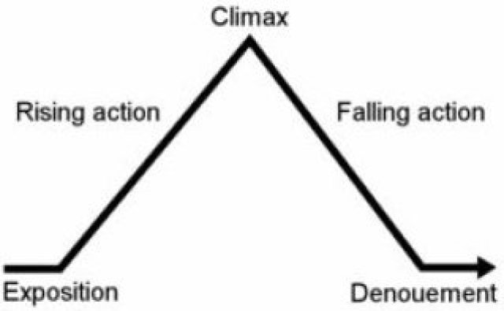
Gustav Freytag (1816 - 1895) was a German dramatist and novelist.
Freytag's Pyramid
1. Exposition: setting the scene. The writer introduces the characters and setting, providing description and background.
2. Inciting Incident: something happens to begin the action. A single event usually signals the beginning of the main conflict. The inciting incident is sometimes called 'the complication'.
3. Rising Action: the story builds and gets more exciting.
4. Climax: the moment of greatest tension in a story. This is often the most exciting event. It is the event that the rising action builds up to and that the falling action follows.
5. Falling Action: events happen as a result of the climax and we know that the story will soon end.
6. Resolution: the character solves the main problem/conflict or someone solves it for him or her.
7. Dénouement: (a French term, pronounced: day-noo-moh) the ending. At this point, any remaining secrets, questions or mysteries which remain after the resolution are solved by the characters or explained by the author. Sometimes the author leaves us to think about the THEME or future possibilities for the characters.

Elements of plot structure
Gustav Freytag (1816 - 1895) was a German dramatist and novelist.
Freytag's Pyramid
1. Exposition: setting the scene. The writer introduces the characters and setting, providing description and background.
2. Inciting Incident: something happens to begin the action. A single event usually signals the beginning of the main conflict. The inciting incident is sometimes called 'the complication'.
3. Rising Action: the story builds and gets more exciting.
4. Climax: the moment of greatest tension in a story. This is often the most exciting event. It is the event that the rising action builds up to and that the falling action follows.
5. Falling Action: events happen as a result of the climax and we know that the story will soon end.
6. Resolution: the character solves the main problem/conflict or someone solves it for him or her.
7. Dénouement: (a French term, pronounced: day-noo-moh) the ending. At this point, any remaining secrets, questions or mysteries which remain after the resolution are solved by the characters or explained by the author. Sometimes the author leaves us to think about the THEME or future possibilities for the characters.

